Addressing Your Mail
The accuracy of the address affects the speed and handling of your mail.

Return Address
Print or type your address in the upper left corner on the front of the envelope.
Extra Services
Place labels for extra services above the delivery address and to the right of the return address, or to the left of the postage.
Postage
Use stamps, a postage meter, or a
PC Postage system to affix the correct amount. You can calculate postage online at pe.usps.com.

Recipient Name

Name of Organization

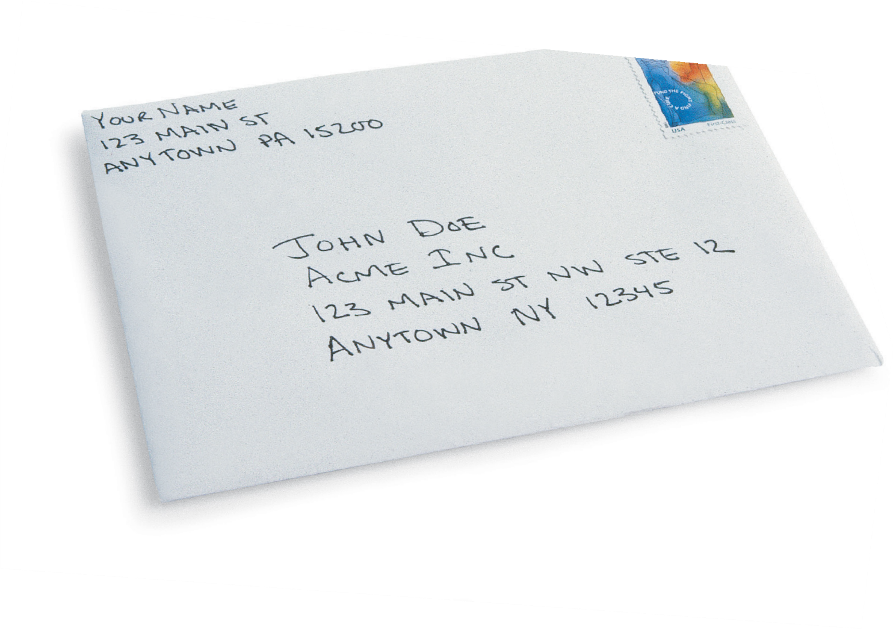
Street Address
Use a Post Office box or street address, but not both. If the address also has a directional (for instance, NW for Northwest), be sure to
use it. There may be more than one Main Street.

12

Apartment or Suite Number The correct apartment or suite number helps to ensure delivery to the right location.

City, State, and ZIP Code
To find the correct spelling of a city name or to find a ZIP Code, visit www.usps.com or call 1·800·ASK·USPS. Using the correct ZIP Code helps to direct your
mail more efficiently and accurately.

